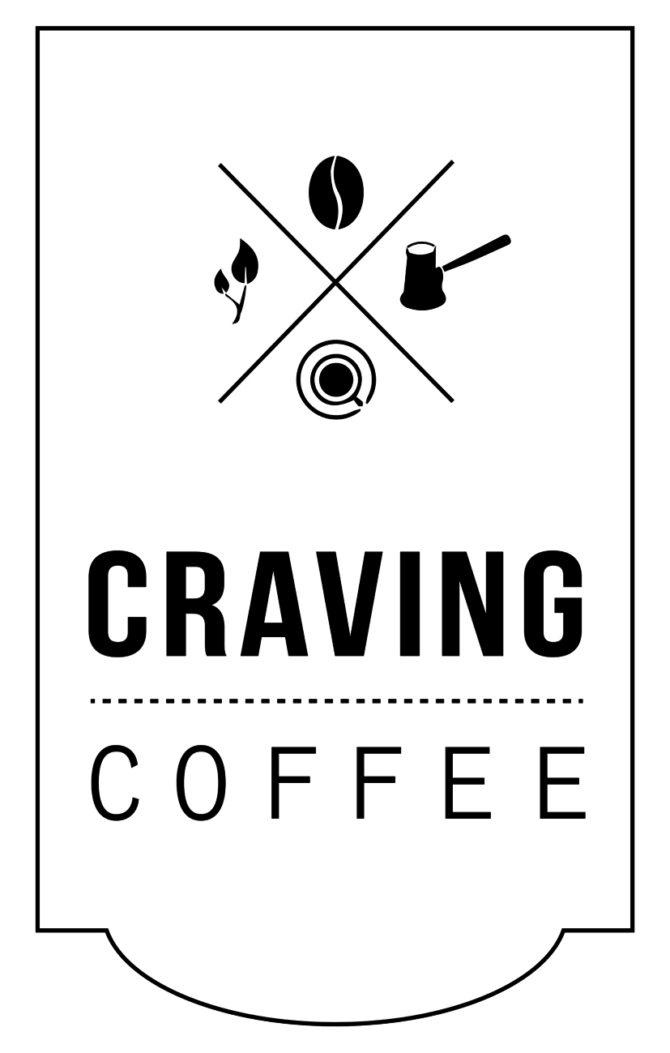

TOTTENHAM SOCIAL APPLICANT INFO PACK

Tottenham Social has been running since June 2015. We open up our kitchen to different street food traders to cook their food in the evenings at Craving Coffee.

We are inviting street food traders to pop up in our kitchen on a Thursday, Friday and Saturday night in 2017.

If you would like to take part, please read the information below and then fill in the online application form.

Who are we looking for?

We welcome London based Street Food Traders who:

- Cook amazing food they are passionate about with an appealing evening menu.
- Have excellent service and rapport with customers.
- Actively promote what they do and have the ability to pull a crowd.
- Are very professional and great people to work with our team.

We can offer:

- A free pitch in our kitchen to serve food for 3 consecutive nights.
- Promotion through our network including our social media, website, mailing list, PR contacts plus flyers designed in-house displayed in our café, on our cart and distributed in the local area.
- Table bookings managed and hosted by our trained staff.

How does it work?

Your pop up will run from a Thursday to a Saturday. Each night runs from 5-11pm, with food service at 6-10pm. Traders are expected to arrive at 4.30pm to start setting up for 6pm sharp.

You can use equipment in our kitchen or bring your own. We have a cooker with 4 induction hobs, an oven & a grill. There are 3 x 13amp power points available in the kitchen for any equipment you want to bring with you.

You need to bring your own:

- cooking utensils i.e. knives, pots & pans (compatible with induction hobs), tongs, scraper etc.
- disposables to serve customers i.e. plates, cutlery, napkins etc.
- cleaning products i.e. antibac spray, blue roll etc.

The number of covers in a night varies from around 25 – 60+, depending on natural fluctuations however we will do our best to inform you of expected covers for each night.

Taking Payments and Running the Floor

You will be responsible to take your own orders & payments, run your own food and clear your own plates from tables. While the Craving bar staff will give you a hand if it gets busy, they are there to run the bar, so you will need to ensure you have enough staff to manage your operations.

Food & Drink Swap

We offer complimentary coffee & tea, plus 2 drinks for each of your staff (draught beer, glass of house wine or bottle of soft drink) in exchange for feeding our bar staff & managers (5-6 staff)

Other Important Details

- The invitation is for food sales only. All drinks sales must be done by our bar.
- Your menu needs to include a few starters or sides, 2-3 mains and at least one veggie option. You may also include a desert.
- All bookings and seating plans will be arranged by Craving Coffee.
- At the end of each night you must clean down the kitchen to how you found it, as it needs to be ready for our morning service.
- If you break any of our equipment, you will be expected to replace it.
- We highly recommend that you are able to take card payments.

Eligibility

You should already be trading and be able to produce the following documents:

- Public Liability Insurance
- Food Hygiene Certificate
- Food Business Registration
- HAACP
- PAT Testing Certificate
- Hi resolution (300dpi) logo and photos of your menu items

You be active online in promoting your brand and the night and have the following:

- Website
- Twitter
- Facebook Page
- Instagram

We look forward to hearing from you!

Love the Craving Team x

